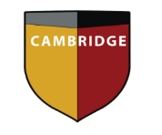
Cambridge International School
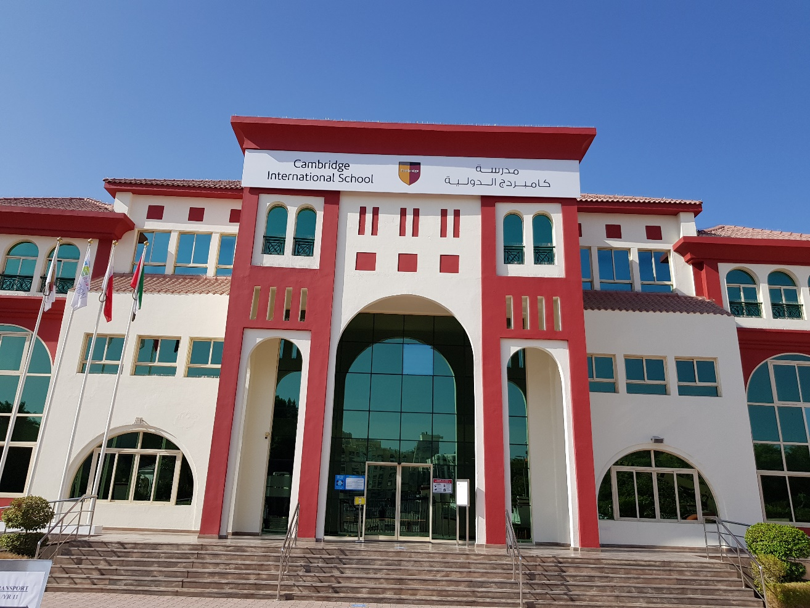
Dubai
Your Choice at Thirteen Plus

Year 10 Option Form
2021-2022

Year 10 -Option List of Options 2021-2022
Mandatory Subjects: English, Mathematics, Social Studies, Physical Education, Moral Education, Islamic Studies (only Muslims), Global Perspectives/ Global Futures (Non- Muslims) and Arabic

Option 1: This subject is already selected in Year 9. Students will continue studying the subject and will sit the external IGCSE examination in Year 10 (May/ June 2022). New students have the option of self- studying the content covered in Year 9.
Option 1 | Option 2 | Option 3 | Option 4 | Option 5
Business | Physics | Chemistry | Biology | Combined Science
Sociology | Biology | ICT | Chemistry | ICT
ICT | Business | Travel & Tourism | Economics | Physics
Computing | Enterprise | Psychology | Art | Psychology
French | Geography | Economics | Environmental M | Business
 | Drama | History | Accounting | Accounting
 | BTEC Creative Media |  | Physical Education | English Literature

Atleast one Science subject (Chemistry, Biology, Physics or Combined Science) must be chosen to fulfil the MOE Equivalency requirement

Please select your first and second preference. You may only select one from each Option block:

 | Option 1 (currently studying in Year 9) | Option 2 | Option 3 | Option 4 | Option 5
First Preference
Second
Preference

All options selected are preferences and subject confirmation is dependent on course numbers, teacher recommendations and CAT4 scores. If we are unable to offer the 1st preference, we will consider the second preference in that particular option block

I, (student name) ______________________________ in class_____ confirm my preferred choices

and recognise that these may be amended after consultation.

Signed________________________ Date ________________

Countersigned (Parent) ________________________

Undertaking of understanding when selecting BTEC courses

I (parent name) ___________________________________ understand that the BTEC courses are not currently recognised by the UAE Ministry of Education and therefore cannot be attested.

At present, the following UAE universities recognise BTEC without attestation- Middlesex, Heriot Watt and The American University in Dubai. Universities outside Dubai may or not recognise the qualification.

Charges for the BTEC courses are payable before completion of the course and are not refundable once the student is enrolled. Registration for BTEC Level 2 courses last year was 2500 AED; this cost is to be reviewed but is a guideline for the charges for the 2021-22 courses.

Signed ___________________________________parent of ____________________________

Signed

(print name in full, as on passport)

gned

in class _______________________________ Date___________________________________

Note: Please return the form to the Media Teacher while joining the course
PATHWAYS
The first step towards your future career is to plan out the journey. The activity below is designed to help you map this out effectively so that you are able to make better-informed decisions. If you have a couple of different careers in mind, you will need to use multiple pathway maps. In order to complete your map, you will need to complete some research

My desired career is…

What qualifications are needed? (i.e. degree, vocational cert’ etc…)

What are the pre-requisites in order to achieve the above/what would be good to do?

What will the Post 16 requirements/needs be?

What levels do I need to access these courses and what am I predicted to achieve?

Subject

Level

CAT4 Prediction
What I need to achieve

